Testing the characteristic of an ESP32 ADC using DAC
https://how2electronics.com/how-to-use-ads1115-16-bit-adc-module-with-esp32/
Object: to test the linearity, offset and gain errors of an ESP32 ADC
by comparison with an ADS1115 16 bit ADC
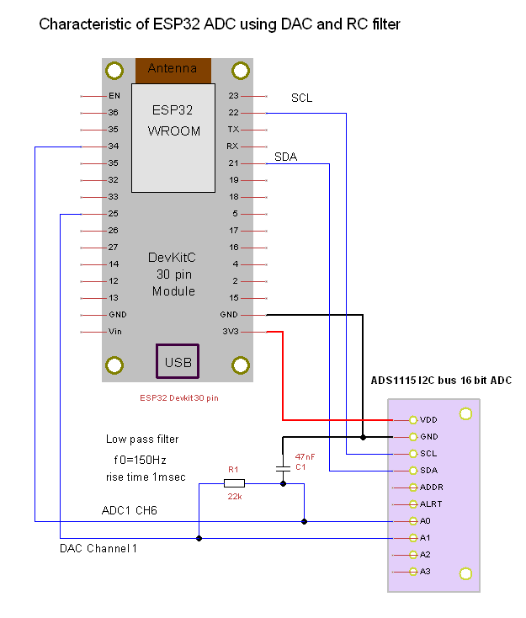
Operation; the ESP32 DAC generates a DC voltage that is applied to the input of both ADC’s
The program generates a series of voltage values from 0 * Vcc/255 to 255 * Vcc/255
For each of those outputs
The program measures the sum of 4 readings from the ESP32 ADC at each of 4 gain settings.
For each of those the reading from the ADS1115 is aggregated, so it’s also a sum of 4 readings.
The program also measures the output from the DAC to check its linearity. (its very good).
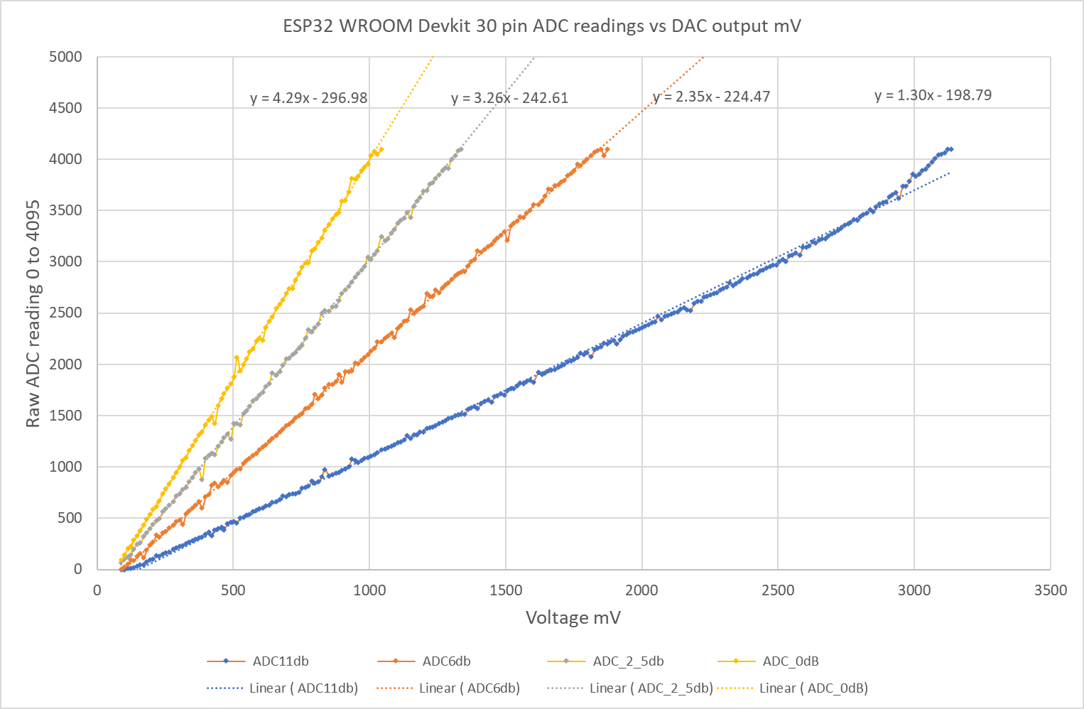

/*
https://randomnerdtutorials.com/esp32-pwm-arduino-ide/
https://how2electronics.com/how-to-use-ads1115-16-bit-adc-module-with-esp32/
ADS1X15 Rob Tillaart installed
*/

/*
experiment using DAC and RC filter to compare ESP32 ADC with readings from ADS1115
program as esp32 dev module
*/

#include <Adafruit_ADS1X15.h>
Adafruit_ADS1115 ads; /* Use this for the 16-bit version */
//Adafruit_ADS1015 ads; /* Use this for the 12-bit version */

const int dac1Pin = 25; // GPIO25, DAC1;
// For a number n (0 - 255) the DAC outputs a voltage n * Vref / 255.
// The default Vref is the 3.3V supply; An external Vref can be used if that pin is exposed on the board

const int vPin = 34; // Voltage to be measured is connected to GPIO 34 (Analog ADC1_CH6)

int16_t anInRaw = 0; // raw reading from ESp32 ADC
int16_t ads0; //raw reading from ads1115

const int tSettle = 50; //settling time between readings

int32_t readings[260][6]; //260 rows of 6 columns, viz: ADS1115 aggregated; ADC11db; ADC6db; ADC_2_5db; ADC_0dB; ADS1115 reading DAC
//

void setup() {

for (int i = 0; i < 259; i++) { readings[i][0] = 0; } //clear this column so ads values can be aggregated
Serial.begin(115200);
delay(2000); //to allow starting & clearing serial monitor
Serial.println("Comparing raw readings of DAC output comparing ADC1_CH6 and ADS1115");

/*
***** INFO FOR ESP32 ADC *****
analogSetAttenuation(attenuation): sets the input attenuation for all ADC pins. Default is ADC_11db. Accepted values:

ADC_0db: sets no attenuation. ADC can measure up to approximately 800 mV ().
ADC_2_5db: The input voltage of ADC will be attenuated, extending the range of measurement to up to approx. 1100 mV. (1V input = ADC reading of 3722).
ADC_6db: The input voltage of ADC will be attenuated, extending the range of measurement to up to approx. 1350 mV. (1V input = ADC reading of 3033).
ADC_11db: The input voltage of ADC will be attenuated, extending the range of measurement to up to approx. 2600 mV. (1V input = ADC reading of 1575).

analogSetPinAttenuation(pin, attenuation): sets the input attenuation for the specified pin. The default is ADC_11db.
*/

analogSetAttenuation(ADC_11db); //just confirming ESP32 ADC is set to default
Serial.println("Analog ADC1_CH6 gain set to -11dB range 0 - 2600mV");

/*
***** INFO FOR ADS1115 *****
The ADC input range (or gain) can be changed via the following functions, but be careful
never to exceed VDD +0.3V max, or to exceed the upper and lower limits if you adjust the input range!
Setting these values incorrectly may destroy your ADC!
ADS1015 ADS1115
------- -------
ads.setGain(GAIN_TWOTHIRDS); // 2/3x gain +/- 6.144V 1 bit = 3mV 0.1875mV (default)
ads.setGain(GAIN_ONE); // 1x gain +/- 4.096V 1 bit = 2mV 0.125mV
ads.setGain(GAIN_TWO); // 2x gain +/- 2.048V 1 bit = 1mV 0.0625mV
ads.setGain(GAIN_FOUR); // 4x gain +/- 1.024V 1 bit = 0.5mV 0.03125mV
ads.setGain(GAIN_EIGHT); // 8x gain +/- 0.512V 1 bit = 0.25mV 0.015625mV
ads.setGain(GAIN_SIXTEEN); // 16x gain +/- 0.256V 1 bit = 0.125mV 0.0078125mV
*/
ads.setGain(GAIN_ONE); //setting gain for the ads1115: 1x gain +/- 4.096V ADS1115 1 bit = 0.125mV
Serial.println("ADS1115 GAIN_ONE ADC Range: +/- 4.096V 1 bit = 0.125mV "); //this is used for all tests

if (!ads.begin()) {
Serial.println("Failed to initialize ADS.");
while (1)
;
}

}

void loop() {
Serial.println("Testing ESP32 ADC using PWM and ADS1115 \n");

analogSetAttenuation(ADC_11db); //just confirming ESP32 ADC is set to default
Serial.println("Analog ADC1_CH6 gain set to -11dB");
for (int i = 0; i <= 256; i++) {
dacWrite(dac1Pin, i); //send value to DAC1
delay(tSettle);
readings[i][0] = ads.readADC_SingleEnded(0);
//take 4 adc readings and aggregate to reduce noise
anInRaw = 0;
for (int j = 0; j < 4; j++) {
anInRaw += analogRead(vPin);
delay(7);
}
readings[i][1] = anInRaw;
}

analogSetAttenuation(ADC_6db);
Serial.println("Analog ADC1_CH6 gain set to -6dB");
for (int i = 0; i <= 256; i++) {
dacWrite(dac1Pin, i); //send value to DAC1
delay(tSettle);
readings[i][0] += ads.readADC_SingleEnded(0);
anInRaw = 0;
for (int j = 0; j < 4; j++) {
anInRaw += analogRead(vPin);
delay(7);
}
readings[i][2] = anInRaw;
}

analogSetAttenuation(ADC_2_5db);
Serial.println("Analog ADC1_CH6 gain set to -2.5dB");
for (int i = 0; i <= 256; i++) {
dacWrite(dac1Pin, i); //send value to DAC1
delay(tSettle);
readings[i][0] += ads.readADC_SingleEnded(0);
anInRaw = 0;
for (int j = 0; j < 4; j++) {
anInRaw += analogRead(vPin);
delay(7);
}
readings[i][3] = anInRaw;
}

analogSetAttenuation(ADC_0db);
Serial.println("Analog ADC1_CH6 gain set to 0dB");
for (int i = 0; i <= 256; i++) {
dacWrite(dac1Pin, i); //send value to DAC1
delay(tSettle);
readings[i][0] += ads.readADC_SingleEnded(0);
anInRaw = 0;
for (int j = 0; j < 4; j++) {
anInRaw += analogRead(vPin);
delay(7);
}
readings[i][4] = anInRaw;
}
//testing DAC1
analogSetAttenuation(ADC_11db); //just confirming ESP32 ADC is set back to default
Serial.println("Testing DAC1");
for (int i = 0; i <= 256; i++) {
dacWrite(dac1Pin, i); //send value to DAC1
delay(tSettle);
readings[i][5] += ads.readADC_SingleEnded(1);
}

Serial.println("*** Run complete ***");

printReadings();

//stop when run complete

while (1) {
};
}

void printReadings() {
Serial.println("each value represents the sum of 4 raw readings");
Serial.println("ADS1115 aggregated over 4 runs; ADC11db; ADC6db; ADC_2_5db; ADC_0dB; ADS1115 reading DAC");

for (int i = 0; i < 259; i++) {
Serial.print(readings[i][0]);
Serial.print(" ,");
Serial.print(readings[i][1]);
Serial.print(" ,");
Serial.print(readings[i][2]);
Serial.print(" ,");
Serial.print(readings[i][3]);
Serial.print(" ,");
Serial.print(readings[i][4]);
Serial.print(" ,");
Serial.print(readings[i][5]);
Serial.print(" ,");
Serial.println("");
}
Serial.println("");
}

